Community Amenities Contributions (CACs) - MVCCA ‘Wish List’ IDEAS

Community Amenities Contribution and Inclusionary Housing Policy (June 2023), contains a general list of CACs and the provision (in section 7), for five areas of Saanich - each with localized amenities and priorities.
Area 1 is Uptown Douglas (also general discussion of CACs at UD Plan Policy 5.6)
Area 3 is ‘Tillicum Carey’ - MVCCA is in a small part of this area.
Generally
- trees and native plants - funding to Parks dep’t for green space improvements on public land
- safe routes to schools for when families move into new housing
- cooling stations to be activated in heat dome situations
- building design that reduces urban heat islands such as green walls and shading
- artwork, murals and sculpture -- especially sculpture designed to be climbed on
- contribute towards widening and solar lights for CRD trails in immediate area - project in planning stage by CRD
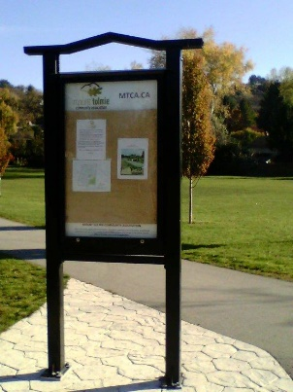
- utilization of roof space
- publicly available electric car recharging stations

Area 1
- full sized Public Library
- Saanich to acquire land for publicly-owned pocket parks or plazas
- begin a fund towards a Saanich owned concert hall (Garth Homer Hall will be closing).
- Bethune Park (tiny neighbourhood park) - upgrade to be done by Parks dep’t
- Boleskine Rd. improvements - see UD Plan section 7.7 (7.7.2- traffic light at Tennyson)
- safer intersections where there are the highest accident rates
- crosswalk lighting at corner of Carey Road and Crease Ave.
- community space for rent that is suitable for events and meetings
- public washrooms facilitated in conjunction with or without BC Transit upgrades.
- Pat Bay Hwy right turn on to Vernon Ave at Apex building – redesign of dangerous intersection –jurisdiction (MOTI)
- Pat Bay Hwy overpass connection from Huxley to Swan Lake
- overpass or underpass connection between Uptown mall and future Uptown Transit exchange
- overpass connection between Uptown and Hansbraun property (at time of the their redevelopment).
- Mt View Park enhancements e.g. community notice board, Fitcore Extreme for ages 13+
Area 3
- Dumeresq St. and Interurban Road - traffic light
- Cadillac Ave. (speed of cut through traffic) - traffic calming measures - jurisdiction Saanich
- community notice board
- redesign corner of Tillicum and Cadillac – there will increased traffic due to two large housing projects

Please add your ideas :

________________________________________________________________________________________

________________________________________________________________________________________

__________________________________________________________________________________________

__________________________________________________________________________________________

