MVCCA 2025 President’s Report

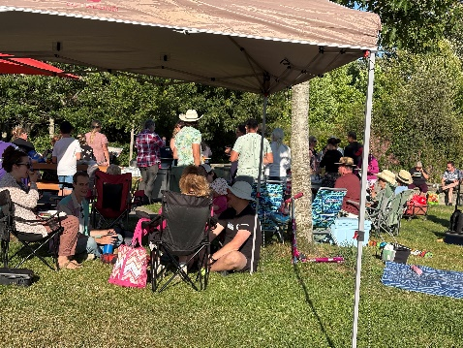
MVCCA volunteers:
- attend the monthly SCAN (Saanich Community Assoc. Network) meetings
- respond in writing, to all Planning Dep’t requests for comment on applications
- form consensus on issues, then write or speak at the appropriate council meeting
- maintain the Mt. View Park native plant garden
- maintain a website that provides information on local issues and events
- provide community news to members via emails and rack cards

neighborhood gathering at Mt. View Park
Local Neighbourhood events
It is wonderful the see all the block parties, community garage sales and Lawncerts happening in our area. If asked, MVCCA could provide a small amounts of funding towards such as event. Also, check out: support from Greater Victoria Placemaking Network https://victoriaplacemaking.ca/

Growth in Saanich Core
The Uptown-Douglas Plan was supposed to encourage and concentrate, density in our Saanich Core. So far none of those tall buildings approved, has begun construction. If densification does not happen in the Core, I think there will be more applications for 6-12 storey buildings outside the Core, where we do not want them.

Growth in Carey area
We are beginning to see a few Small-Scale, Multi-Unit Housing (SSMUH) projects in our area (213 Crease Ave and 588 Whiteside St.), but most current construction is single house sized projects.

Amalgamation Report
The report from the Citizen’s Assembly tasked with exploring the costs, benefits and disadvantages of the amalgamation between the District of Saanich and the City of Victoria is now available. The question of amalgamation will be on the ballot in the next BC local elections (17 Oct 2026).

Our community garden
Needs a lot of work.

Our new website https://mvcca.ca from The Indivision Network
This site and domain name is accessed through a local company and is much less costly that the one we had from a US company.

Transportation
Uptown Transit Hub (Uptown TOD) The bus stop changes along Carey Road, Ravine and Hwy #1, are an interim bus exchange measure, suggesting that the hub will not be anytime soon. The Tillicum Active Transportation Bridge Project (overpass at Tillicum and Hwy#1) will begin construction early 2026, after completion of the widening of the highway near that location.

Community Engagement
Neighbourhoods are made from the small acts of many people. Please report graffiti, abandoned cars, dumps of garbage, damage to public property. These simply actions have a tangible impact. To have a voice, explore the Saanich website and the council agendas. It is easy to receive updates on specific topics and to complete surveys. Citizens are welcome on Saanich advisory committees.

Saanichmap
This is an interactive map that now contains a tab for the Planning Dep’t. It is very useful and includes the boundaries of TOAs (transit oriented areas) and existing planning applications.

Thank you for your interest in your community.

Carol Hamill - 21 Oct. 2025

Local News
731 Burnside Rd. – youth bike skills park and nature preserve. No word if MOTI will allow use of the adjacent property (741 Burnside Road). The plan for the site will include, the upper half to be retained as nature preserve (after the death of the owner) and the section near the trail to become a bike park. It may be necessary to lobby on behalf of the project, when it is presented to council for funding.

